C3 Project: Restaurant Finder: Part 1

Use Case Diagram:-

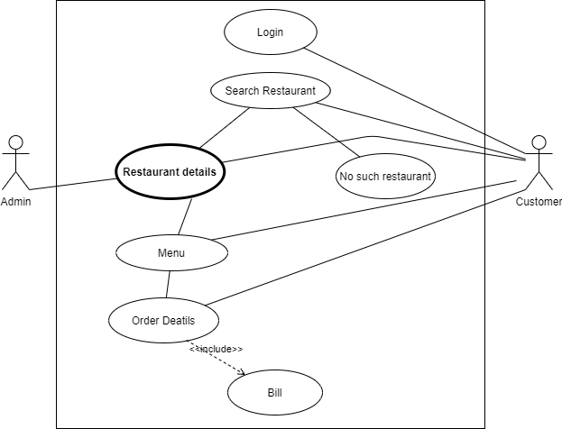

Activity Diagram:-

